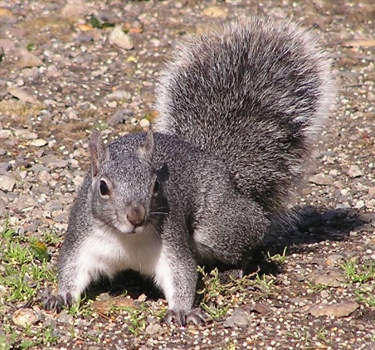



How Do Invasive Plants Spread?
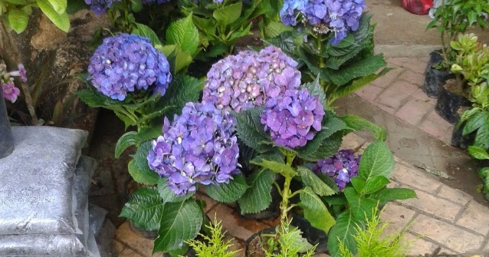
Invasive Plants
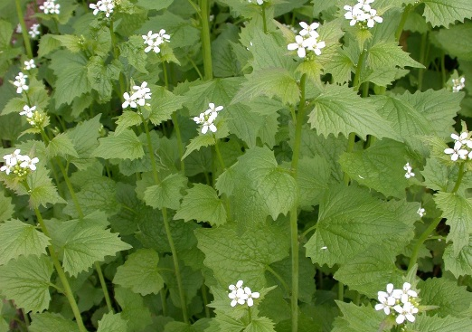
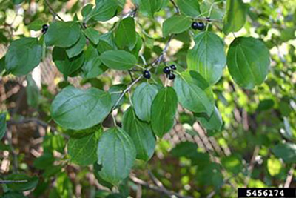
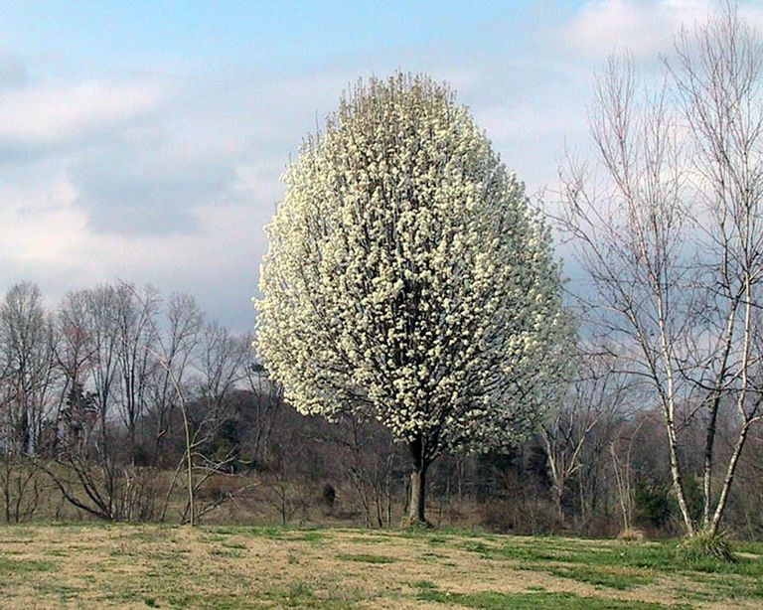
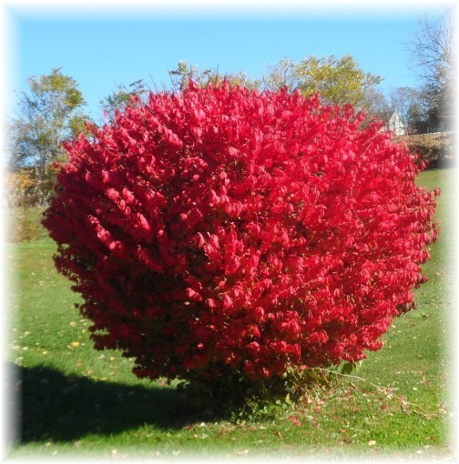
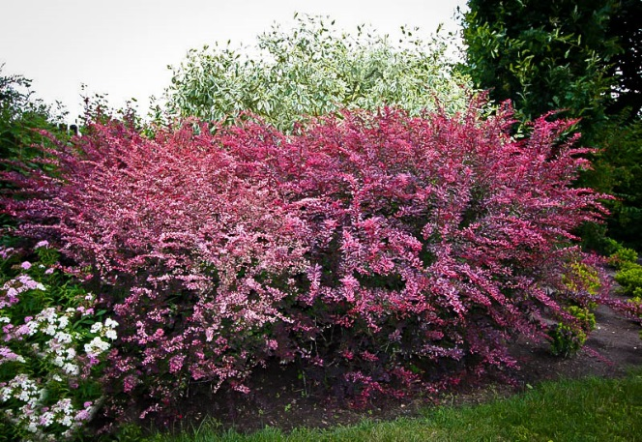

Garlic Mustard
Common Buckthorn
Callery Pear
Burning Bush
Barberry
Amur Maple
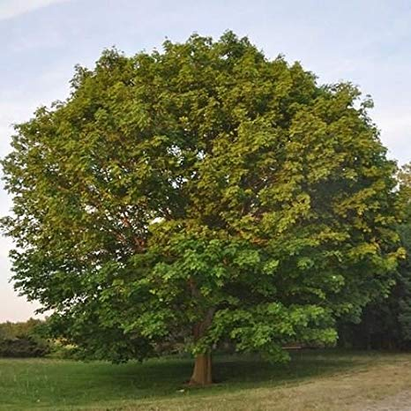
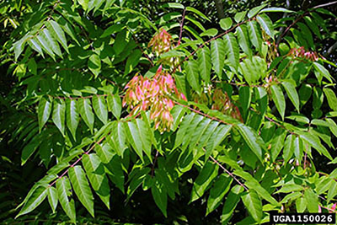

Invasive Plants
Purple Loosestrife
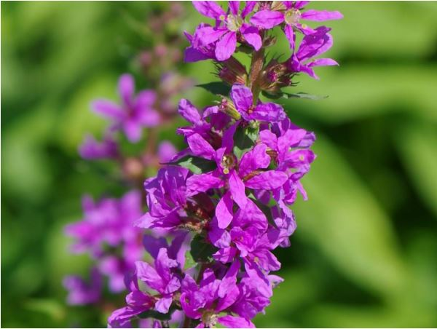
Tree of Heaven
Norway Maple
Kudzu
Aggressive Plants
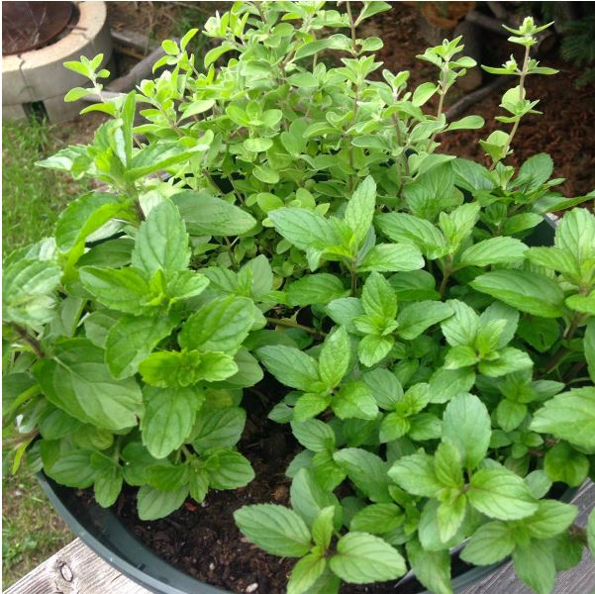

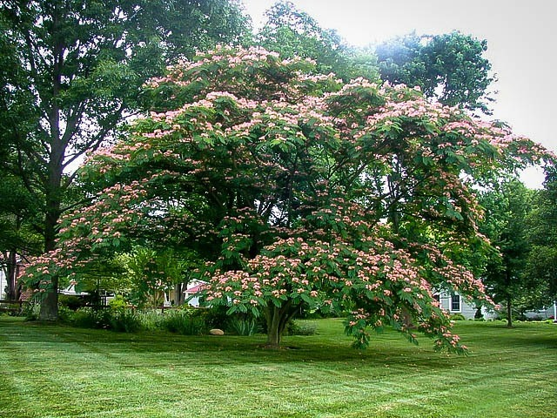
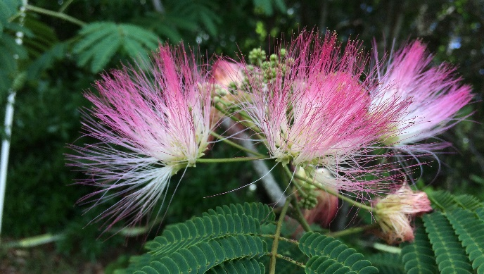
Bamboo
Mimosa Tree
Mint
Aggressive Plants
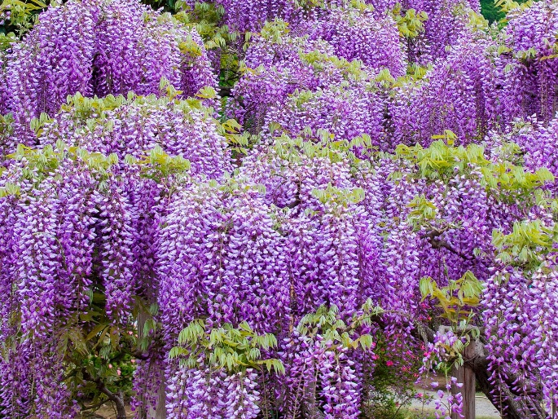
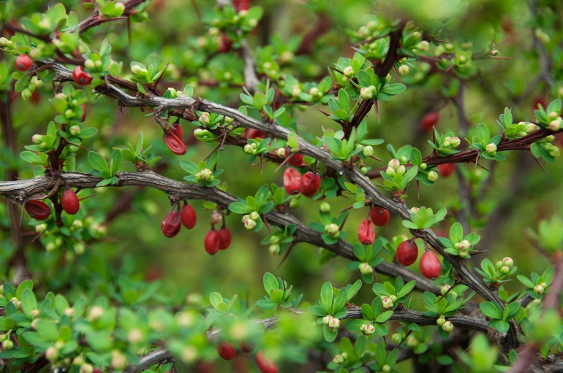
Wisteria
Japanese Barberry
Avoiding Invasive Plants
- Learn which plants in your area are considered invasive
- Don’t plant any non-native plants with fleshy fruits
- Avoid planting any species that have escaped into vacant lots or roadsides
- Whenever possible, select regionally native plants


Managing Aggressive Plants

Certain Plants Are Highly Susceptible to Harsh Weather Conditions




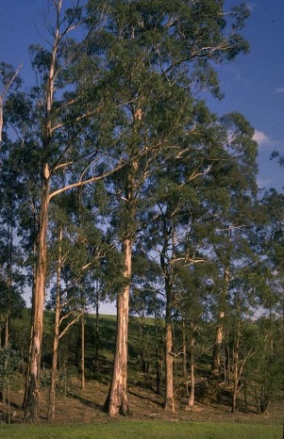

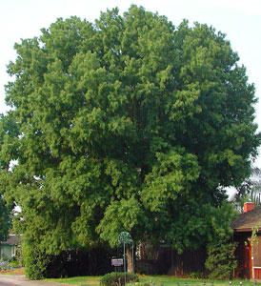

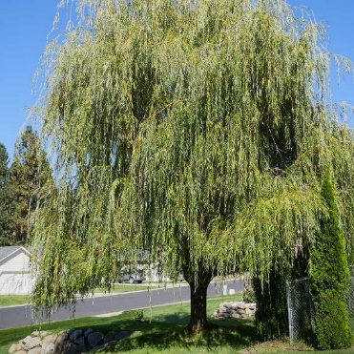
Certain Plants Are Highly Susceptible to Harsh Weather Conditions
American Oak
Pear Trees
Silver Maple
Sycamore
Willow
Eucalyptus
Wind-Resistant Trees


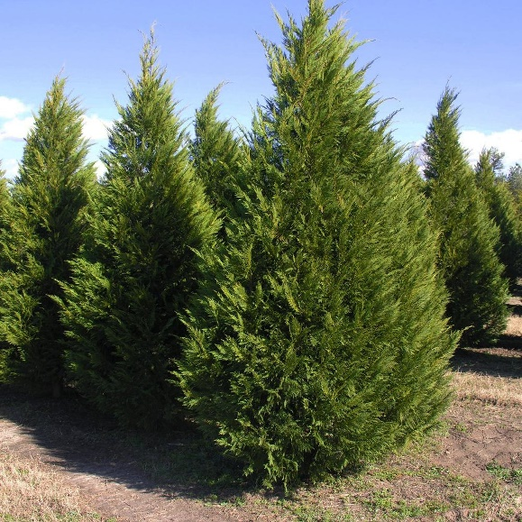

Tulip Tree
Live Oak
Cypress
Crepe Myrtle

Toxic Flowering Plants

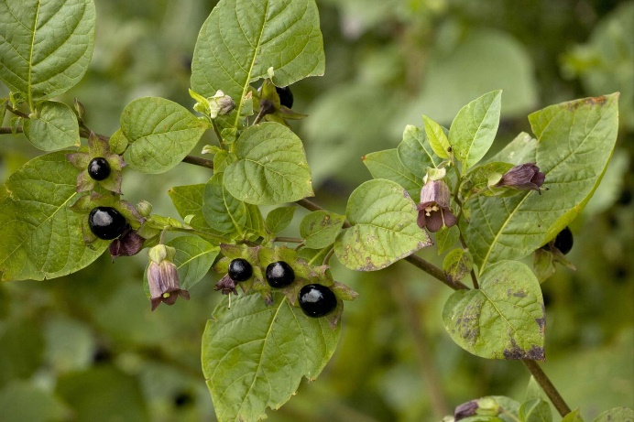
Belladonna (a.k.a. Deadly Nightshade)
- A low-maintenance decorative shrub that is a good choice for beginning gardeners
- Named for Atropos, the oldest of the group of three weaving Greek goddesses who determined the fate of every mortal
  - It’s from her that we get the name of the plant’s toxin, atropine
- One of the deadliest plants on earth
  - A small chewed leaf is enough to kill an adult
  - Symptoms of ingestion include dilating pupils and dry mouth, hallucinations, very loud heart beats (which even people standing close to the victim can hear), convulsions and coma
  - Symptoms can occur hours after ingesting the plant or even a few days later on
- A low-maintenance decorative shrub that is a good choice for beginning gardeners
- Named for Atropos, the oldest of the group of three weaving Greek goddesses who determined the fate of every mortal
  - It’s from her that we get the name of the plant’s toxin, atropine
- One of the deadliest plants on earth
  - A small chewed leaf is enough to kill an adult
  - Symptoms of ingestion include dilating pupils and dry mouth, hallucinations, very loud heart beats (which even people standing close to the victim can hear), convulsions and coma
  - Symptoms can occur hours after ingesting the plant or even a few days later on
Brugmansia (a.k.a. Angel’s Trumpet)
- An easy to grow shrub that thrives in tropical and subtropical climate with cool nights and warm days
- Flowers are white, yellow, pink, orange or creamy
- A member of the nightshade family, with all parts containing toxic alkaloids
  - These include, but are not limited to scopolamine, hyoscyamine and atropine
  - Highest concentration of these toxins is found in the seeds and leaves
- Wear gloves when handling
  - Touching eyes or food with contaminated hands is one of the easy ways to get poisoned
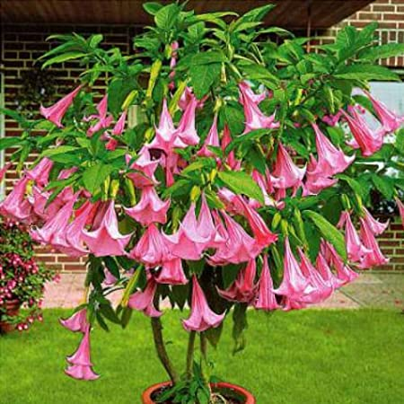
- An easy to grow shrub that thrives in tropical and subtropical climate with cool nights and warm days
- Flowers are white, yellow, pink, orange or creamy
- A member of the nightshade family, with all parts containing toxic alkaloids
  - These include, but are not limited to scopolamine, hyoscyamine and atropine
  - Highest concentration of these toxins is found in the seeds and leaves
- Wear gloves when handling
  - Touching eyes or food with contaminated hands is one of the easy ways to get poisoned

Daffodil
- One of the first garden plants to bloom in the springtime
- Different parts of the plant have a mildly toxic effect
  - If you keep a bouquet of daffodils in your house for too long, you can get a headache
  - Other symptoms of poisoning include vomiting, diarrhea, dehydration, drooling and stomach ache
  - Tremors, convulsions and heart irregularities have also been reported, especially in pets
- Poisoning usually isn’t fatal, but symptoms are unpleasant
- One of the first garden plants to bloom in the springtime
- Different parts of the plant have a mildly toxic effect
  - If you keep a bouquet of daffodils in your house for too long, you can get a headache
  - Other symptoms of poisoning include vomiting, diarrhea, dehydration, drooling and stomach ache
  - Tremors, convulsions and heart irregularities have also been reported, especially in pets
- Poisoning usually isn’t fatal, but symptoms are unpleasant
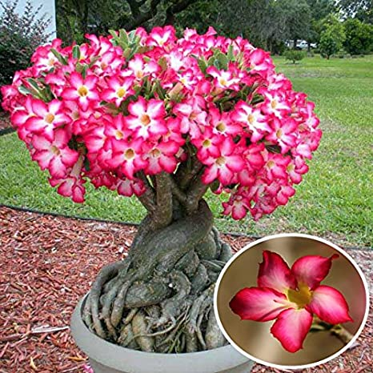
Adenium (a.k.a. Desert Rose)
- Contains ouabain, a cardiac glycoside, and one of the deadliest poisons known to man
  - Ingestion causes vomiting, diarrhea, mouth and throat blisters, drooling and intestinal pain
  - African tribes dip their arrows into the flower’s sap before a hunt
  - A single arrow can kill an elephant after several hours
- It’s very important to protect pets and children from coming in contact with this plant
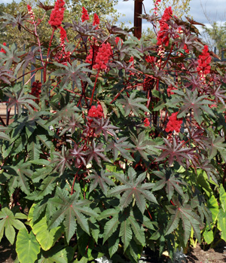
Castor Bean
- Native to tropical east Africa around Ethiopia
- Grown in gardens as an ornamental
- The spiny ovaries of the female develop into a fruit or seed capsule about the size of a golf ball after pollination
  - Pod eventually dries to brown, then splits open and forcibly ejects the seeds
- Seeds are highly toxic
  - Contain ricin, one of the deadliest natural poisons, estimated as 6,000 times more poisonous than cyanide and 12,000 times more poisonous than rattlesnake venom.
  - As few as four seeds can kill an average-sized adult
  - Ingestion of lesser amounts will result in vomiting, severe abdominal pain, diarrhea, and convulsions
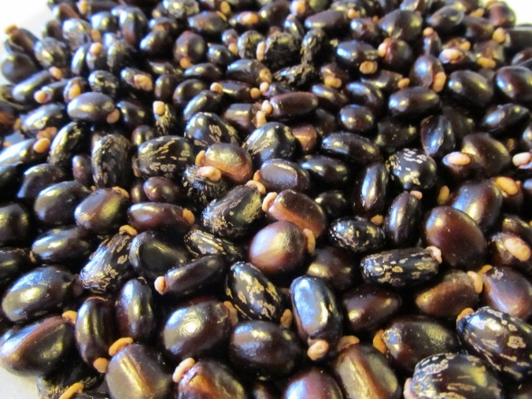
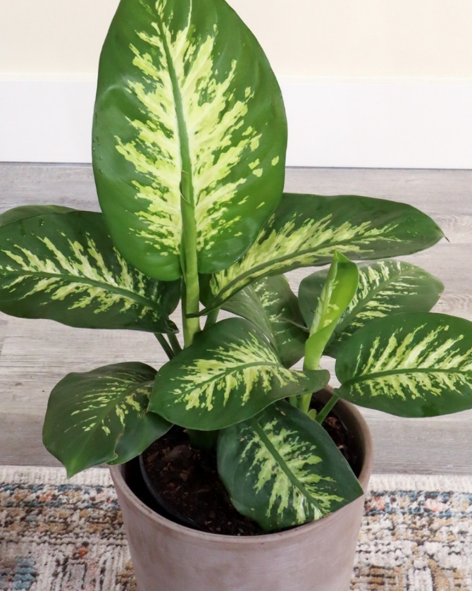
Dumb Cane
- Grown in homes and institutions for its patterned leaves of dark green, light green, white and yellow
- Ingesting the plant’s chemical components are not fatal, but the plant is well-named
  - Some severe cases of swelling after ingesting the plant have resulted in losing the ability to talk
  - In general, the oxalate toxin can cause intense pain and burning that can last for at least half a day
  - Don’t touch the sap
    - If you do, wash your hands before touching your face or eyes
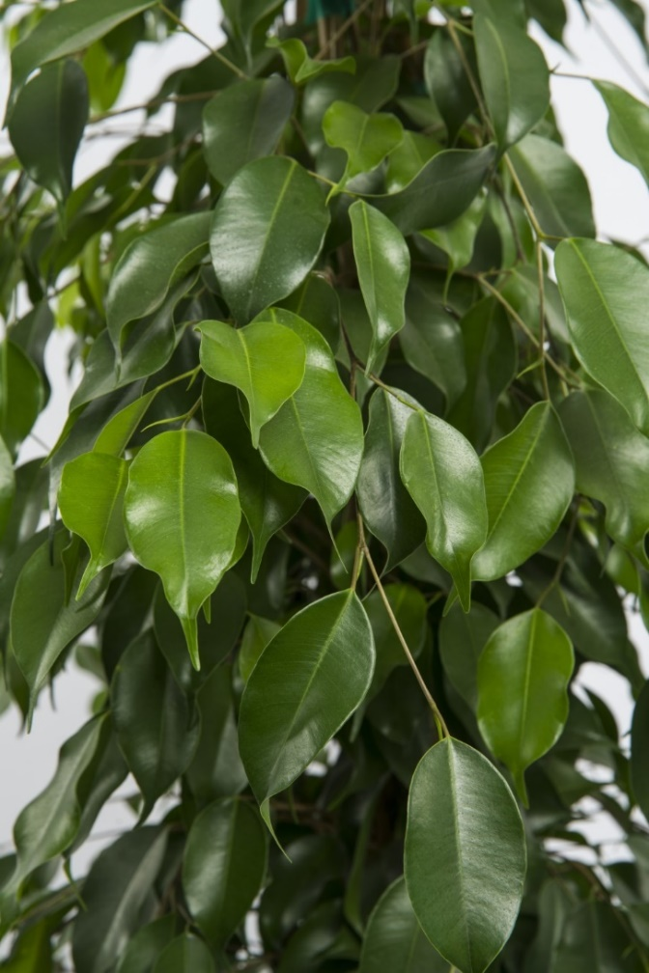
Ficus (a.k.a. Rubber Plant)
- Native to Southeast Asia and Australia
- Grown for its beautiful and thick, tree-like crown
- In warmer climates, can thrive outdoors
- Thrives as a houseplant
  - This can be dangerous for children and pets, as the plant is toxic
  - Children can get an itching or rash from touching the plant
  - Pets might have a worse reaction – as well as stomach aches or diarrhea
- Fortunately, the poison is not fatal
- Native to Southeast Asia and Australia
- Grown for its beautiful and thick, tree-like crown
- In warmer climates, can thrive outdoors
- Thrives as a houseplant
  - This can be dangerous for children and pets, as the plant is toxic
  - Children can get an itching or rash from touching the plant
  - Pets might have a worse reaction – as well as stomach aches or diarrhea
- Fortunately, the poison is not fatal

Hydrangea
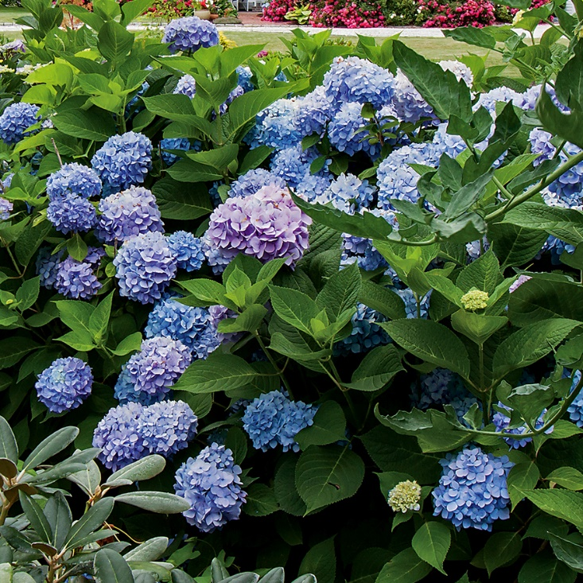
- A medium-sized bush
- Can grow as climbing vines and trees, but are most commonly grown as a shrub
- Flowers bloom in a variety of colors -- pink, blue, red, white, purple and green
- All parts contain low levels of cyanide
  - Moderately toxic for children and pets; less so adult humans
- Symptoms of poisoning include vomiting, heavy breathing, lethargy, stomach ache and, in worst cases, coma.
Foxglove
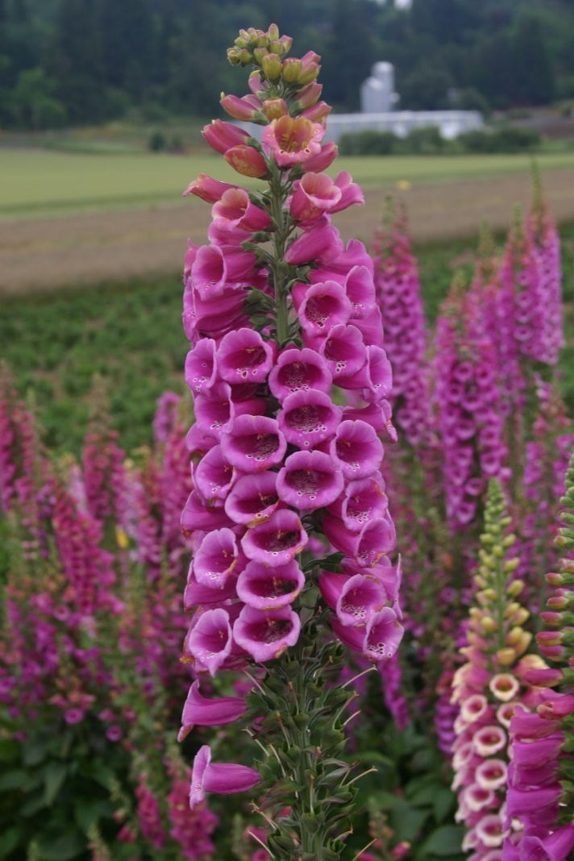
- Bell-like blossoms make it a popular decorative plant
- Also use to make heart stimulating medications
  - Properly refined and administered, the chemicals can be a life-saver
  - Ingested directly, however, the chemicals are highly toxic
- If you plant foxglove, keep an eye on children and pets playing around them
  - Poisoning symptoms include increased heart rate, nausea, vomiting, and seizures
  - In severe cases, antidotes may be needed
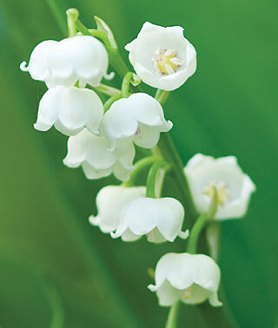
Lily of the Valley
- One of the most fragrant blooming plants in the spring and early summer throughout the northern temperate zone.
- A perennial plant in USDA zones 2-9
- Early symptoms of ingestion include fatigue, diarrhea and vomiting
- Extreme symptoms include irregular heart beat and mental confusion
  - Even a small dosage is enough to kill pets and children
- Wash hands thoroughly after touching the plant
  - Better yet – wear gloves
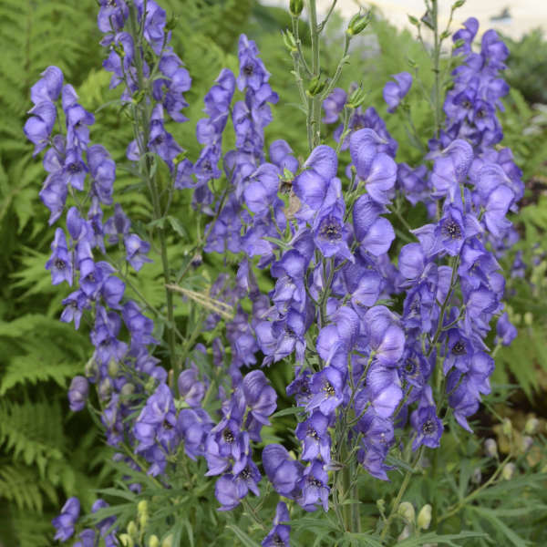
Monkshood (a.k.a. Wolfsbane)
- Originates from the Akonitos mountain in Anatolia
  - According to Greek mythology, when Hercules captured Cerberus and brought him to the surface from the underworld of Hades, the three-headed hound began to howl and salivate. Where the saliva hit the ground, wolfsbane grew
- Used as a “werewolf finder”
  - When the flower was close to the chest of the suspect and a yellowish shadow thrown from the plant appeared, the person was considered to be a werewolf.
- One of the most poisonous in the world
  - So toxic, that if you touch the plant, then touch your face or food, you may have to be rushed to a hospital
  - Hunters would dip their arrows in the poison and hunt game with it
Oleander
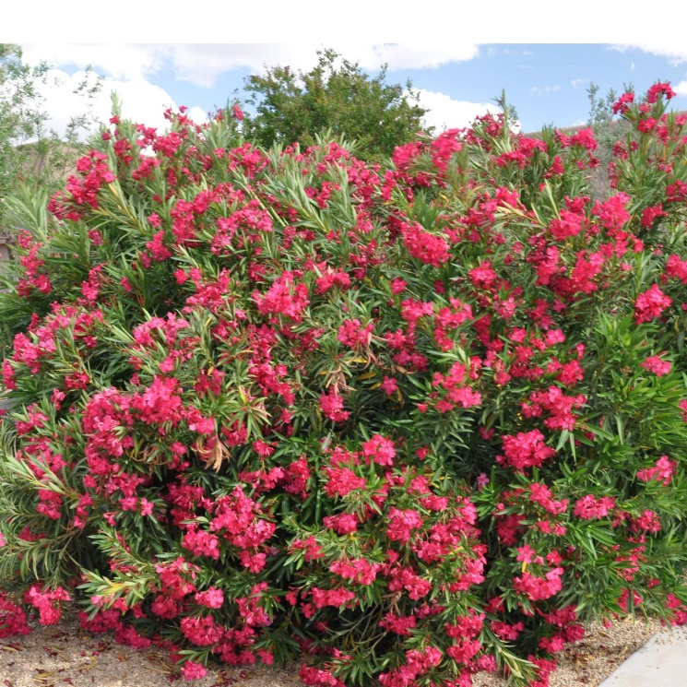
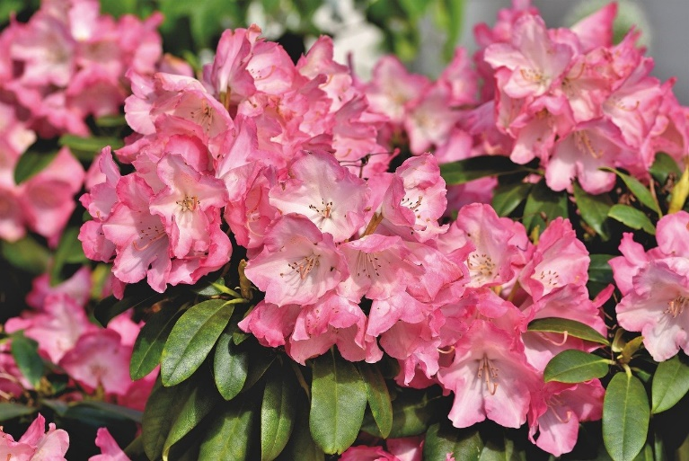
Rhododendron
- A flowering perennial evergreen highly valued for its decorative beauty
- Easy to maintain, which is why it’s used around the world to decorate gardens and parks
- Properly refined, its chemical substances can be used to heal heart disease
- Unrefined however, those same chemicals are a most deadly toxin
  - Toxicity symptoms include drowsiness, vomiting, slowed heart rate, arrhythmias, seizures and tremors
  - Smoke from burning the plants is also toxic
- Come in both evergreen and deciduous cultivars – all of them having oval leathery leaves.
- Bloom in April and May for around 3-4 weeks in different colors – red, violet, white, pink, yellow and blue, as well as in different color combinations
- Plant parts (especially the nectar) contain grayanotoxin, ingestion of which can cause vomiting, confusion, and cardiac problems
  - Honey extracted from rhododendrons was known as “mad honey”
  - An adult human or a large human would have to eat hundreds of flowers to get poisoned
  - Ingestion by a smaller animal, such as a cat or dog, however, can be fatal.
Water Hemlock
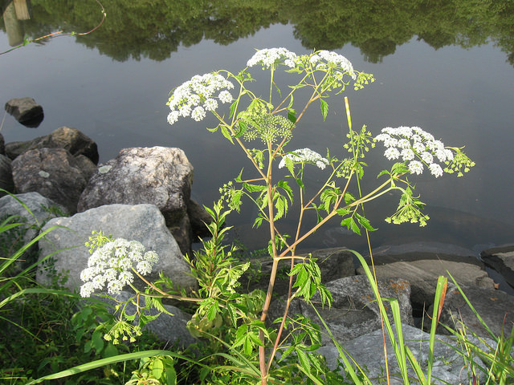
- One of the most poisonous plants in nature
  - This is what Socrates had to drink for his execution
- Not a garden plant, but a weed
  - Easily confused with a blooming carrot
  - Looks and smells harmless
- Main toxic ingredient is cicutoxin
  - Even a small amount can poison livestock, pets or humans
  - It works by attacking the central nervous system, leading to seizures and eventual death
- If you find it in your yard, use a tool or wear strong gloves to uproot it

Toxic Houseplants

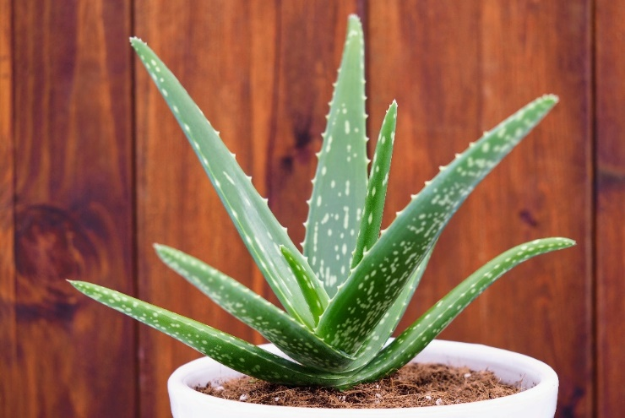
Aloe
- A succulent plant native to South Africa
- Widely used in medicine and in textile industry
- The juice extracted from the leaves has an antibacterial and skin soothing effect
- The juice, however, is covered by a thin layer of aloin, a highly toxic substance
  - Ingestion of large amounts leads to stomach disorders, anorexia and depression
  - In rare cases, tremors have been known to occur
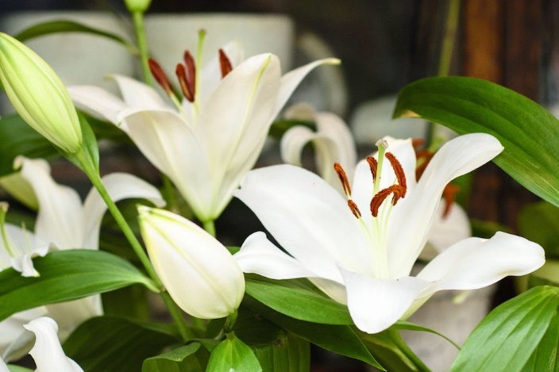
Asian Lilly
- A popular plant at Easter time
- Toxic to cats
  - Toxicity symptoms include vomiting, inappetence, lethargy, kidney failure, and death.
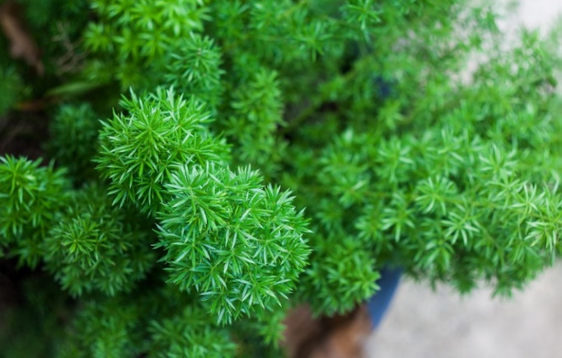
Asparagus Fern
- Thrives in warm, humid environments
  - A great plant to keep in your bathroom
- Toxic to both dogs and cats
  - Symptoms of poisoning include allergic dermatitis with repeated dermal exposure. Berry ingestion could result in gastric upset (vomiting, abdominal pain, or diarrhea).
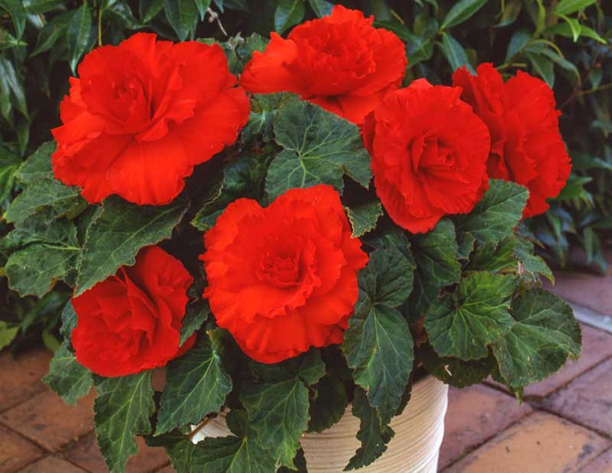
Begonia
- An excellent houseplant for low-light conditions
  - Plant grows well without direct lighting
- Poisonous to dogs, cats, and grazing animals
  - Symptoms include kidney failure (in grazing animals), vomiting, and salivation in dogs/cats.
  - The most toxic part is under the soil.
Bird of Paradise
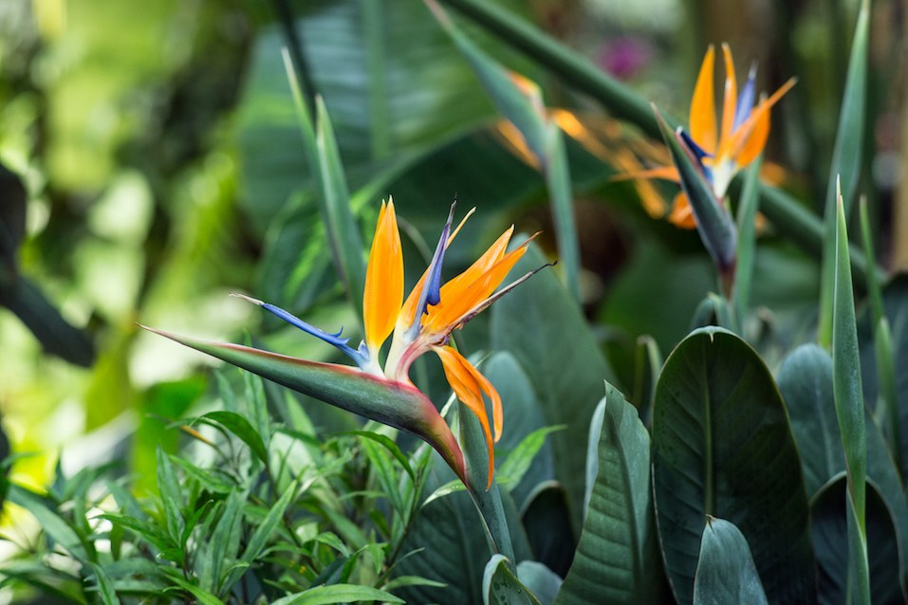
- Also known as the crane flower or bird's tongue flower
- With proper care, the bird of paradise can grow to more than 6 feet in height, and its banana-like leaves can reach 28 inches in length
- Toxic to dogs and cats, according to the ASPCA
  - Toxicity symptoms include mild nausea, vomiting, drowsiness; mainly caused by fruit and seeds
Branching Ivy
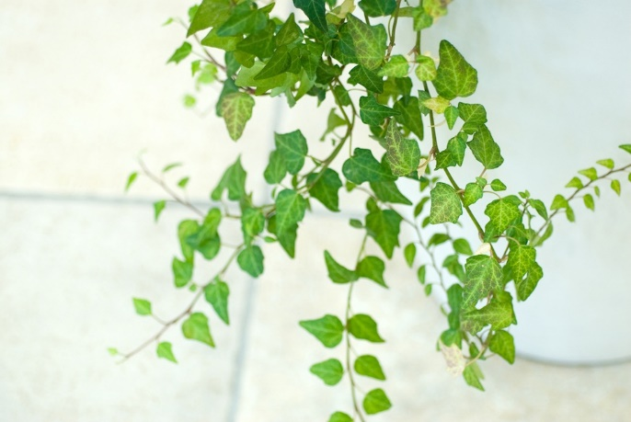
- An excellent houseplant for generating oxygen in the household and filtering common toxins out of the air
- Poisonous to both dogs and cats
  - Triterpenoid saponins (hederagenin) in the plant can cause vomiting, abdominal pain, hypersalivation, and diarrhea.
  - Foliage is generally more toxic than the berries
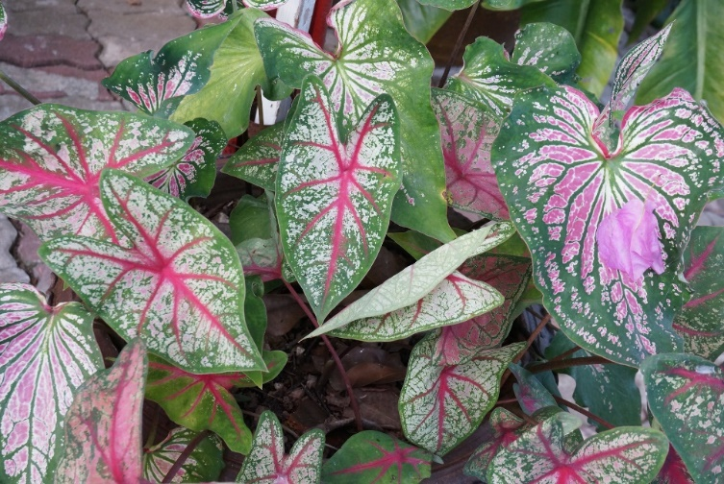
Caladium (Elephant Ear)
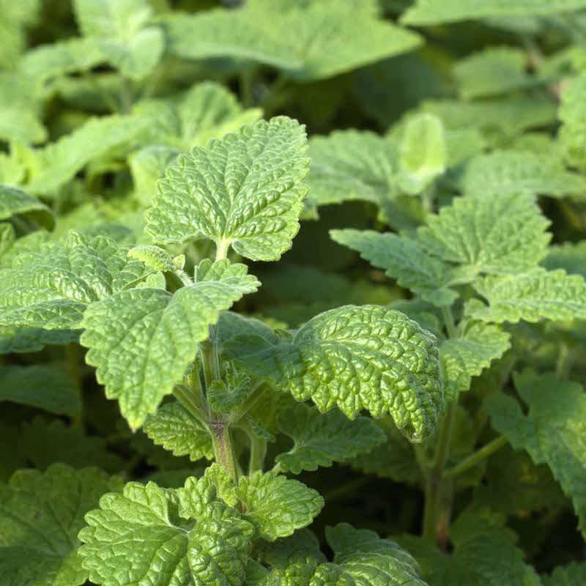
Catnip
- A native of South America grown for its colorful leaves
- Contains calcium oxalate crystals, which can cause damage when chewed
- Poisoning symptoms include vomiting, drooling, swelling tongue and oral cavity, which can cause breathing problems
  - Symptoms are not life-threatening, but medical aid should be sought if any part of the plant is ingested
- People will often give their cats catnip to keep them entertained.
- Cats love it, but according to the ASPCA, it can be toxic for them
- It can stimulate some cats and sedate others
- Too much of the fresh plant can overstimulate the central nervous system and cause cats to injure themselves
Cornstalk Plant
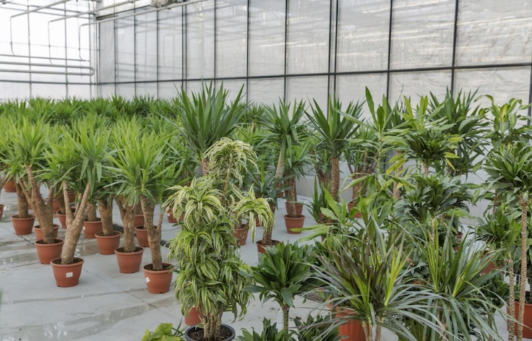
- Also known as the corn plant, dracaena, dragon tree, or ribbon plant
- An excellent plant for purifying the air in your home
- Toxic to dogs and cats
- Saponins in the foliage can cause vomiting (occasionally with blood), depression, anorexia, hypersalivation, and dilated pupils (cats).
Fig Tree
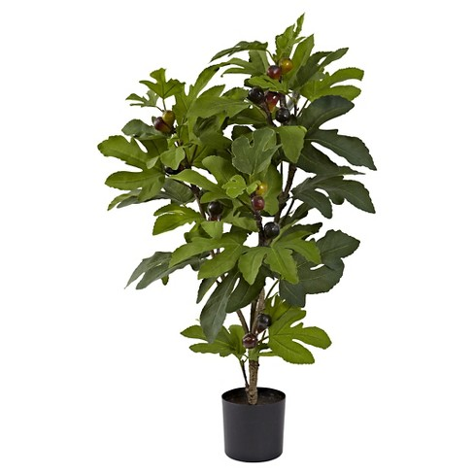
- Also known as the weeping fig or Indian rubber plant
- Toxic to dogs, cats, and horses
- Two toxins – ficin and psoralen (ficusin) can, if ingested, cause gastrointestinal and dermal irritation
Golden Bird’s Nest
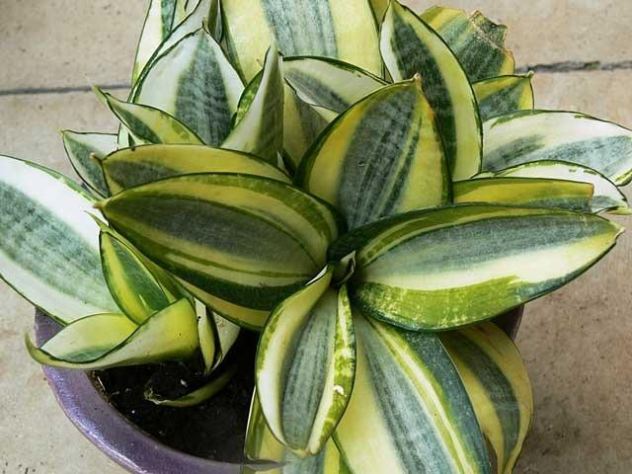
- Also known as the snake plant, mother-in-law’s tongue, and good luck plant
- An easy plant to grow – requires little maintenance
  - Some would go so far as to say that it thrives on neglect
- Toxic to dogs and cats
  - Symptoms of poisoning include nausea, vomiting, diarrhea, caused by the saponins in the foliage
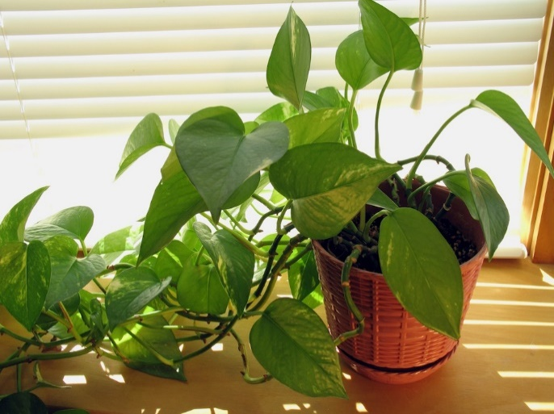
Golden Pothos
- Also known as devil’s ivy, taro vine, and ivy arum
- Another easy to grow houseplant that’s hard to kill
- Toxic to dogs and cats
  - Calcium oxalates in the plant cause oral irritation, intense burning and irritation of mouth, tongue and lips, excessive drooling, vomiting, difficulty swallowing
Jade Plant
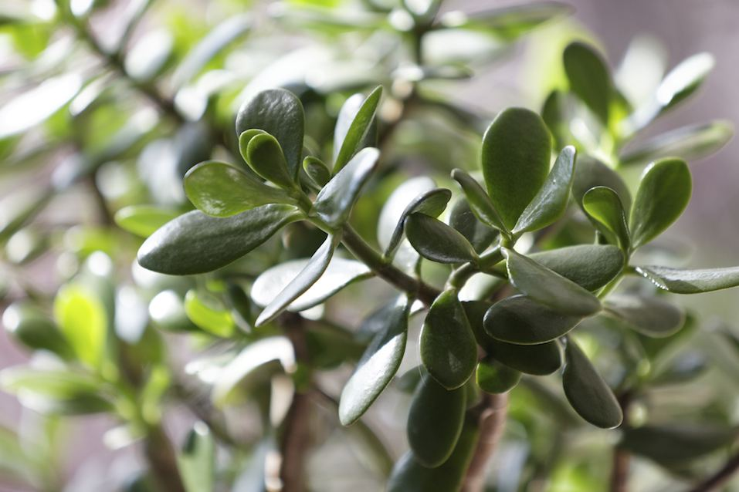
- A good houseplant to buy if you tend to forget to water regularly
- Toxic to dogs and cats
  - Poisoning symptoms include vomiting, depression, incoordination
Lemon Tree
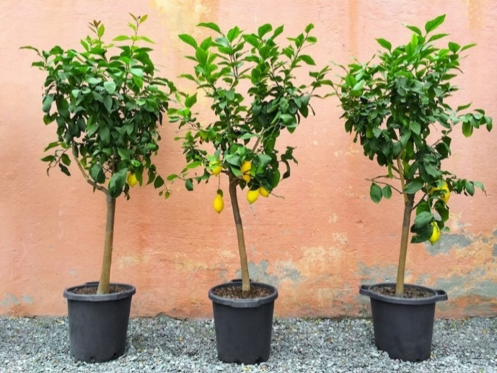
- An easy to grow citrus tree that will produce fruit if you hand-pollinate the flowers
- Can be grown outdoors in spring and summer and brought into the house in fall and winter
- Poisonous to cats and dogs
  - The essential oils and psoralens cause vomiting, diarrhea, depression; potential dermatitis.
  - Fruit is edible, skins and plant material can cause problems
Octopus Tree
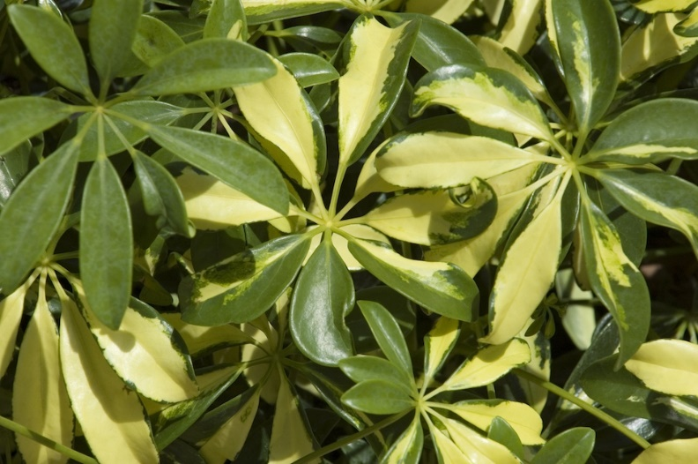
- Also called the umbrella plant or the starleaf
- Two different species with leaflets of different size
- Both species are toxic to cats and dogs
  - Symptoms include mild vomiting and diarrhea, caused by terpenoids, saponins, and insoluble oxalates in the foliage
Peace Lily
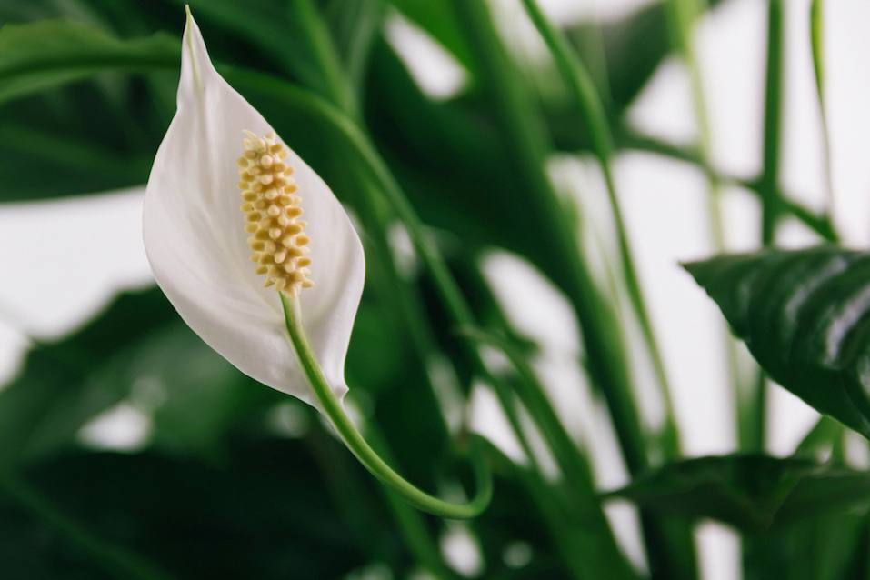
- Another easy to care for plant that grows well even in poor lighting.
- On NASA’s list of best plants for purifying the air
- Poisonous for cats and dogs

Philodendron
- Native to the tropical forests of South America
- Also known as the “weeping tree,” because when the humidity in the air increases, large water drops form on the leaf edges and drip down
- Toxicity symptoms include salivation, mouth burning and tongue swelling
- Poisoning usually isn’t fatal
  - Oxalate toxins have been intensively researched and results show that humans are resistant to the effects of the oxalate
  - The same cannot be said for pets
Pencil Cactus
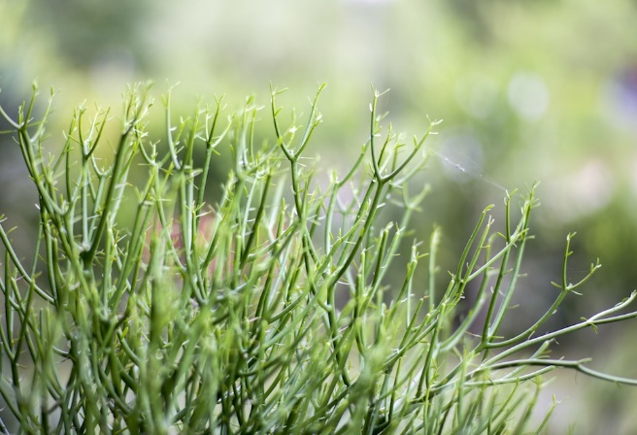
- A popular houseplant that is not only easy to care for, but looks good as well
- Contains an irritating sap that is toxic to both dogs and cats
  - Irritating to the mouth and stomach, sometimes causing vomiting, but generally over-rated in toxicity
- The sap can also irritate skin and eyes of humans

Toxic Parts of Vegetable Crops

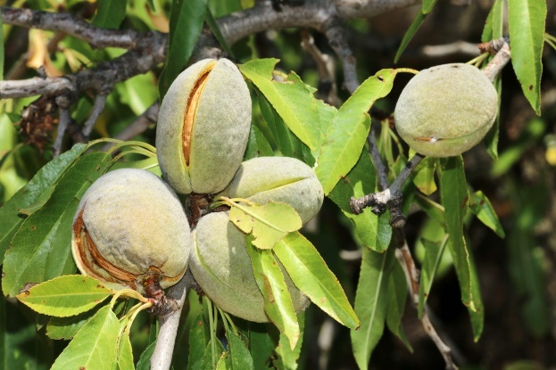
Almond
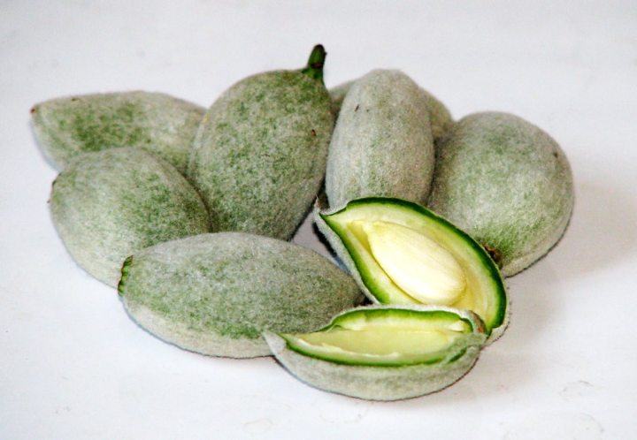
- The almonds that we buy today are known as sweet almonds because the toxins have been bred out of them
- Wild almonds, however, are known as bitter almonds, and every part of the tree is toxic – even the nut
  - The nut, or kernel, contains amygdalin, which the human body converts to cyanide
  - A few raw kernels are toxic enough to kill a small child
  - Must be roasted to be made safe for eating
- Bitter almonds are viewed as more flavorful than sweet almonds
  - Favored by chefs
  - Sale is prohibited in North America
Apple
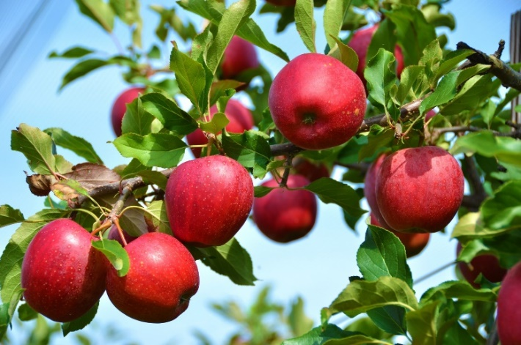
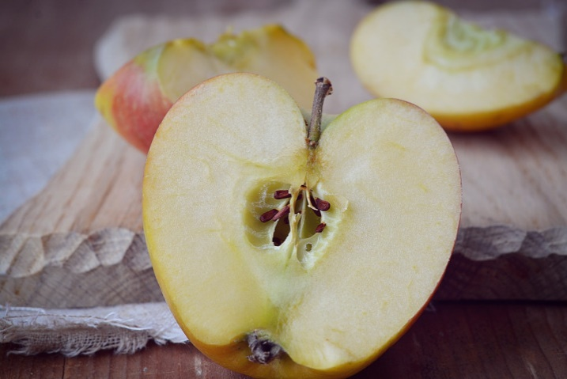
- Apple seeds contain amygdalin, which the human body converts to cyanide
  - If you accidentally swallow a few seeds whole, they’ll pass through your digestive system harmlessly
  - However, if you chew the seeds before swallowing, you’ll release the toxin, resulting in a trip to the hospital
- The leaves and stem of the trees also are poisonous
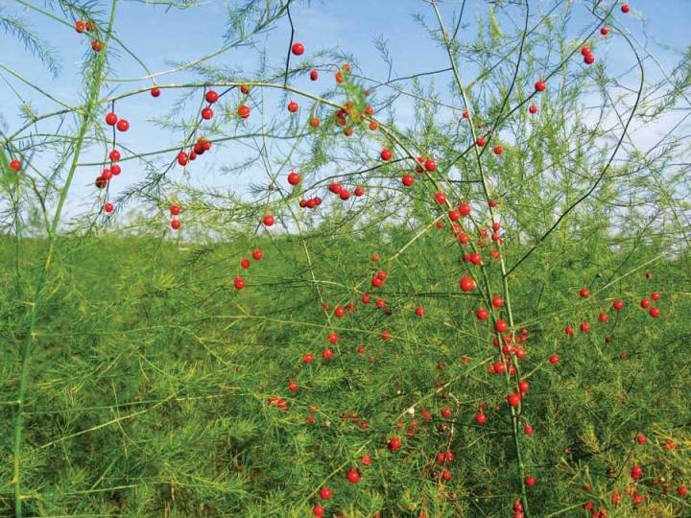
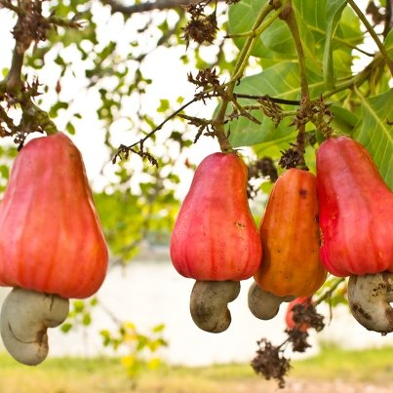
Asparagus
Cashew
- The shoots are edible
- The berries produced by the mature plant have a slight toxicity
- The raw nut is highly poisonous
  - It must be shelled and roasted to destroy the toxin
- The fruit, or cashew “apple” is edible, and can be eaten raw
  - The “apple” is commonly consumed in many tropical countries
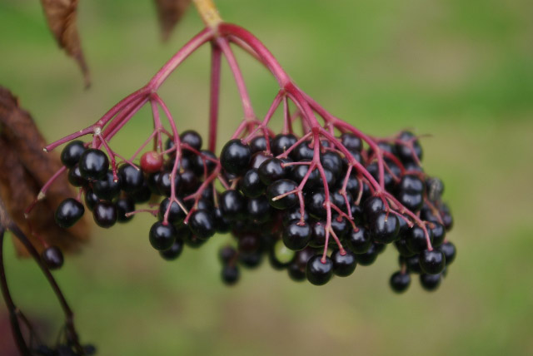
Elderberry
- All parts of the plant, including the raw berries, are toxic
  - The berries must be cooked before eating
  - Technically, the ripe berries can be eaten, however, it is difficult to do so without consuming the seeds, which, if broken, will release their toxin
  - This is why it’s better to cook the berries, as the heat of cooking will inactivate the toxin in the seeds
- Red elderberries are even more toxic than black elderberries
Kidney Bean

- Raw kidney beans contain the toxin phytohemagglutinin
  - Eating five raw beans can send an adult to the hospital
- The beans must be soaked for several hours (usually overnight) and then boiled for at least ten minutes
  - This will reduce the toxin to a safe level
  - Accidents can occur when the beans are soaked, but not properly roasted
Pit Fruits (Plum, Cherry, Peach)

- Fruits are edible
- Leaves, stems and pits are toxic
  - Contain amygdalin
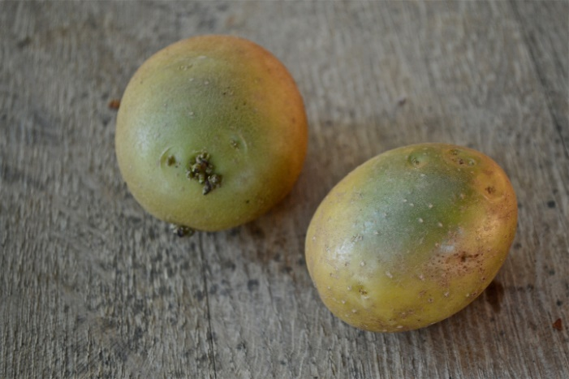
Potato
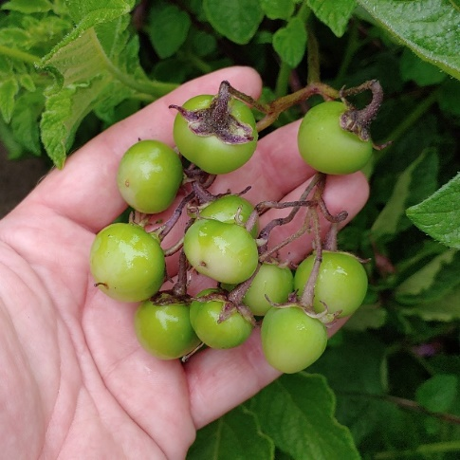
- The tuber is the only edible part
- Roots, leaves, stems, flowers and especially berries are toxic
- Tubers exposed to the sun will turn green
  - The green part contains the toxin solanine
  - Tubers that have some green to them can be eaten, provided the green part is cut away
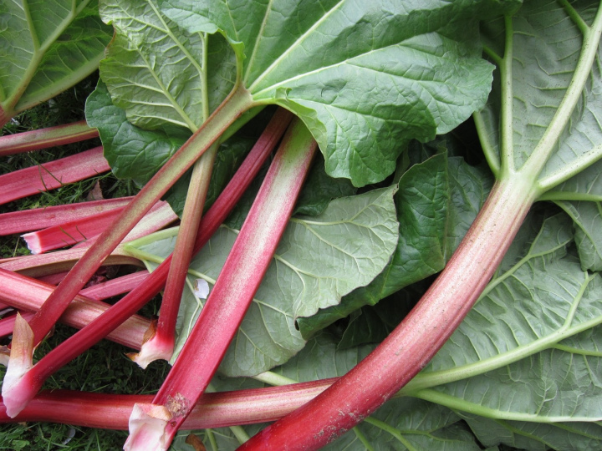
Rhubarb
- The leaf petiole is the only edible part
- The leaf blade contains large quantities of oxalic acid
  - Oxalic acid, if consumed in large quantities, can be toxic to humans
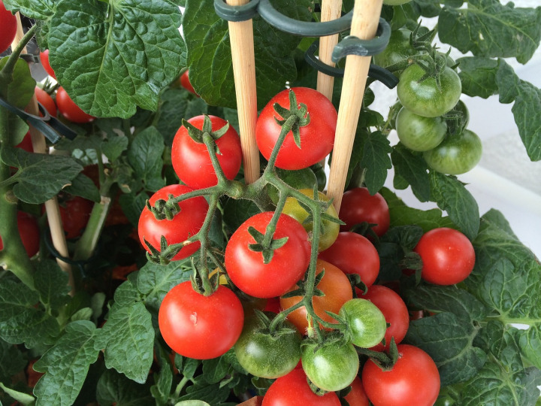
Tomato
- All parts of the tomato, except the ripe fruit, are toxic, but only mildly so
- The green parts contain the toxins tomatine, solanine and other alkaloids, but quantities are small – not enough to cause serious toxicity
- Green tomatoes are slightly toxic, but you’d have to consume about 500 lb. before you felt any effects from the toxins

Avoid Being Poisoned By Your Garden Vegetables
- Do not assume that just because one part of a plant is edible, the rest must also be so
- A plant that is edible cooked is not necessarily edible raw
- Just because it grows in your vegetable garden doesn’t necessarily mean that it is edible

What to Do If You Suspect a Poisoning
- Recognize the symptoms
  - The poisonous plant substances would most likely either cause a skin rash from external contact or digestive trouble from swallowing parts of the plants. The latter can cause vomiting, fainting, and seizures
- Call a doctor, or a vet
  - Immediately call a professional physician once you see somebody showing symptoms
- Provide some comfort
  - While waiting for the specialist, you can help by making the victim comfortable.
    - If the poisoning is external, remove the contaminated clothes
    - If poisoning occurred due to ingestion, remove anything still present in the person’s (or pet’s) mouth. They might keep vomiting, even if they have fainted, so you have to turn them on their side, so they do not suffocate.
- CPR in extreme cases
  - Unfortunately, poisoning with certain plants can cause fatality before the medical staff arrives. If the person is not showing any sign of life, you’ll have to administer CPR – it might save their life until the doctor arrives.




